CS 255 System Design Document Template

UML Diagrams

UML Use Case Diagram

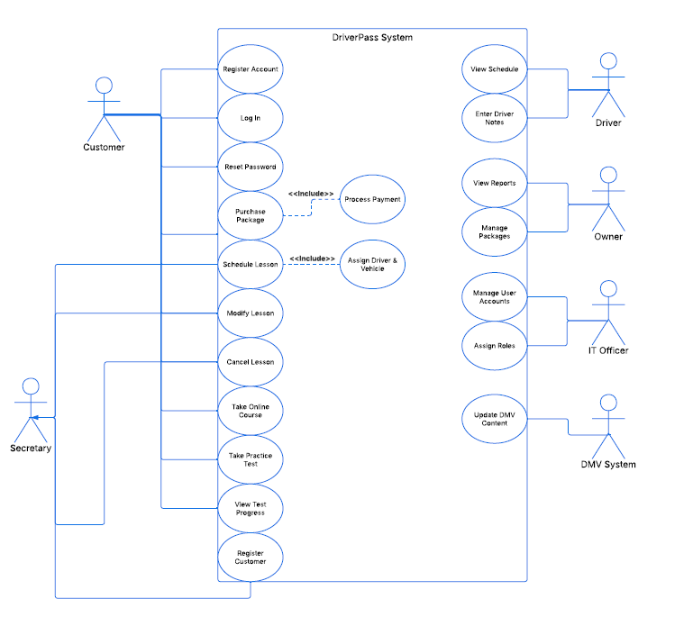

UML Activity Diagrams

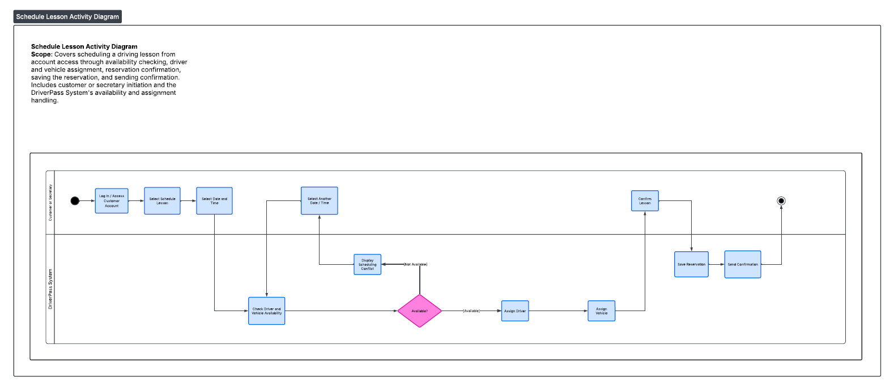

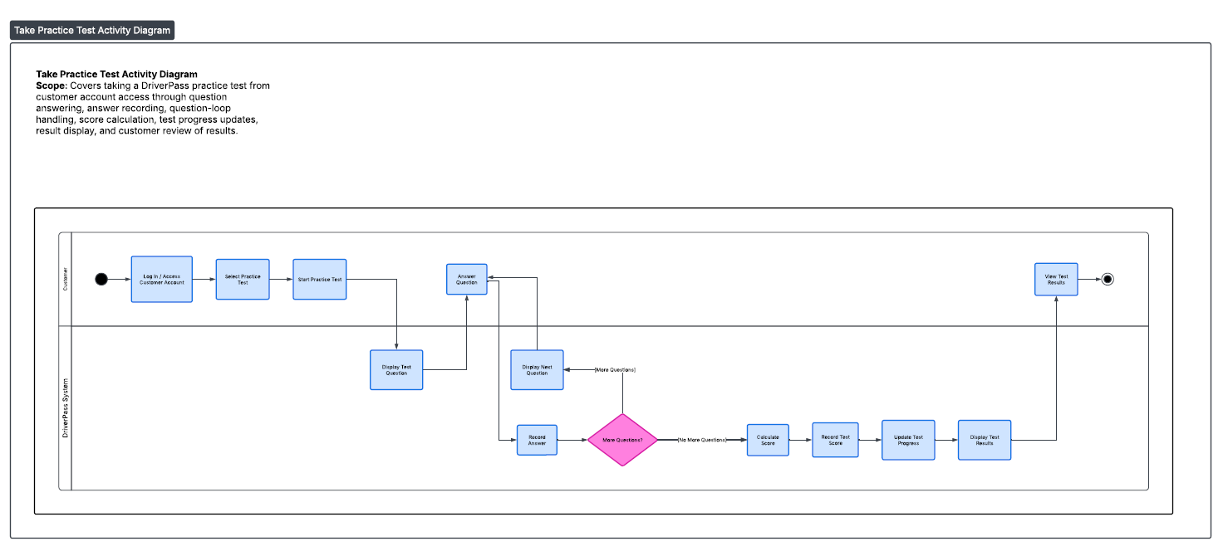

UML Sequence Diagram

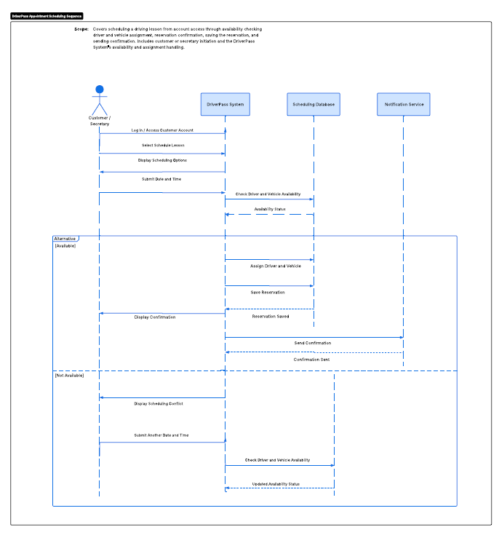

UML Class Diagram

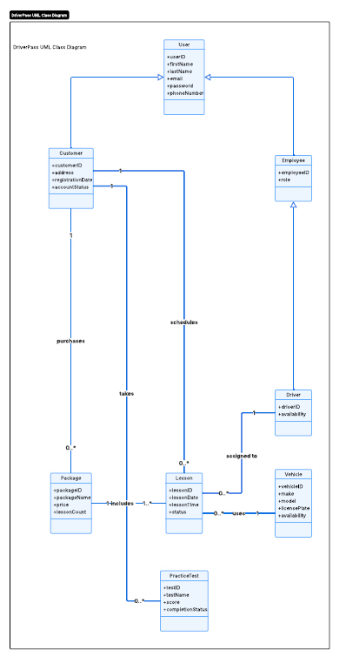

Technical Requirements

The DriverPass system will require a combination of hardware, software, development tools, and network infrastructure to support the functions represented in the UML diagrams. The system must provide customers with reliable online access to create and manage accounts, purchase packages, take online courses and practice tests, view progress, and schedule driving lessons. Employees will also require access to manage schedules, customer information, packages, reports, and other administrative functions.

Hardware

DriverPass will require server resources capable of hosting the web application, application services, and database used to store customer accounts, scheduling information, practice test results, package information, driver availability, and vehicle availability. Employee workstations will require computers with reliable internet access and modern web browsers. Customers should be able to access the system through common internet-connected devices such as desktop computers, laptops, tablets, and smartphones without requiring specialized hardware.

Software

The system should use a web-based application so customers and employees can access DriverPass through a standard web browser. A relational database management system will be required to maintain customer, employee, driver, vehicle, lesson, package, and practice-test information. The application will also require authentication and role-based access controls so customers and employees can access only the functions appropriate to their roles. The system should support secure payment processing for package purchases and provide notification capabilities for scheduling confirmations and other customer communications.

Development and Management Tools

Development tools should support the design, implementation, testing, and maintenance of the DriverPass application and database. UML modeling tools can be used to maintain system documentation and communicate future design changes. Source-control software should be used to track application changes and support collaboration among developers. Testing and monitoring tools should also be available to verify application functionality, identify errors, and maintain system performance.

Infrastructure and Security

DriverPass will require reliable network and internet infrastructure that allows customers and employees to securely access the system. The application and database should be hosted in an environment that provides sufficient availability, storage, processing capability, and scalability as the number of users increases. Secure HTTPS connections should protect information transmitted between users and the system. Passwords and other sensitive information should be securely stored, and access permissions should be based on user roles. Regular backups should protect customer, scheduling, test, and business data from loss. The infrastructure should also support system updates and maintenance while minimizing disruption to customers and employees.

